Experiment 6: Missionaries and Cannibals Problem

Aim:
To solve the Missionaries and Cannibals problem using Breadth-First Search (BFS) by safely transporting 3 missionaries and 3 cannibals across a river using a boat that can carry one or two persons, ensuring missionaries are never outnumbered by cannibals on either bank.

Algorithm:
Step 1: Define State Representation
Represent each state as a tuple: (M_left, C_left, Boat_side)
- M_left: missionaries on left bank
- C_left: cannibals on left bank
- Boat_side: 1 = boat on left, 0 = boat on right

Step 2: Define Validity Rules
A state is valid only if:
- No count is negative
- Missionaries are not outnumbered by cannibals on either bank
- Boat moves 1 or 2 persons Step 3: Generate Successor States Possible moves:
- (1 missionary)
- (2 missionaries)
- (1 cannibal)
- (2 cannibals)
- (1 missionary + 1 cannibal) Apply moves depending on boat side.

Step 4: Use BFS
- Start from initial state (3,3,1)
- Explore all valid next states
- Avoid repeated states
- Stop when reaching goal (0,0,0)

Step 5: Output Solution Path
Print the sequence of states showing safe transitions.

Flowchart:



Source Code:
# Missionaries and Cannibals Problem # Using Breadth-First Search (BFS)

from collections import deque

# State format: (M_left, C_left, boat_side) # boat_side = 1 → boat on left bank
# boat_side = 0 → boat on right bank

def is_valid(state):
M_left, C_left, boat = state M_right = 3 - M_left C_right = 3 - C_left

# No negative values allowed
if M_left < 0 or C_left < 0 or M_right < 0 or C_right < 0: return False

# Missionaries must not be outnumbered on either side if (M_left > 0 and M_left < C_left):
return False
if (M_right > 0 and M_right < C_right): return False

return True

def get_successors(state):

M_left, C_left, boat = state successors = []

# Possible boat moves: (missionaries, cannibals) moves = [(1,0), (2,0), (0,1), (0,2), (1,1)]

for M, C in moves:
if boat == 1: # boat on left bank → move people to right new_state = (M_left - M, C_left - C, 0)
else: # boat on right bank → move people to left new_state = (M_left + M, C_left + C, 1)

if is_valid(new_state): successors.append(new_state)

return successors

def bfs(start, goal):
queue = deque([(start, [start])]) visited = set([start])

while queue:
state, path = queue.popleft()

if state == goal: return path

for next_state in get_successors(state):

if next_state not in visited: visited.add(next_state) queue.append((next_state, path + [next_state]))

return None

# Initial and goal states start_state = (3, 3, 1)
goal_state = (0, 0, 0)

solution = bfs(start_state, goal_state)

print("\n=== Missionaries & Cannibals Solution ===") if solution:
for step in solution: print(step)
else:
print("No solution found.")

Output:
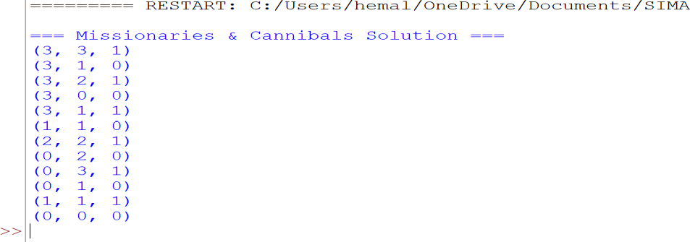

Result:
The Missionaries and Cannibals problem was solved using BFS. Each state is represented as (M_left, C_left, Boat_side).
The algorithm successfully found a safe sequence of moves that transfers all 3 missionaries and 3 cannibals from the left bank to the right bank without ever allowing cannibals to outnumber missionaries on either side.
The final output sequence ends with:

